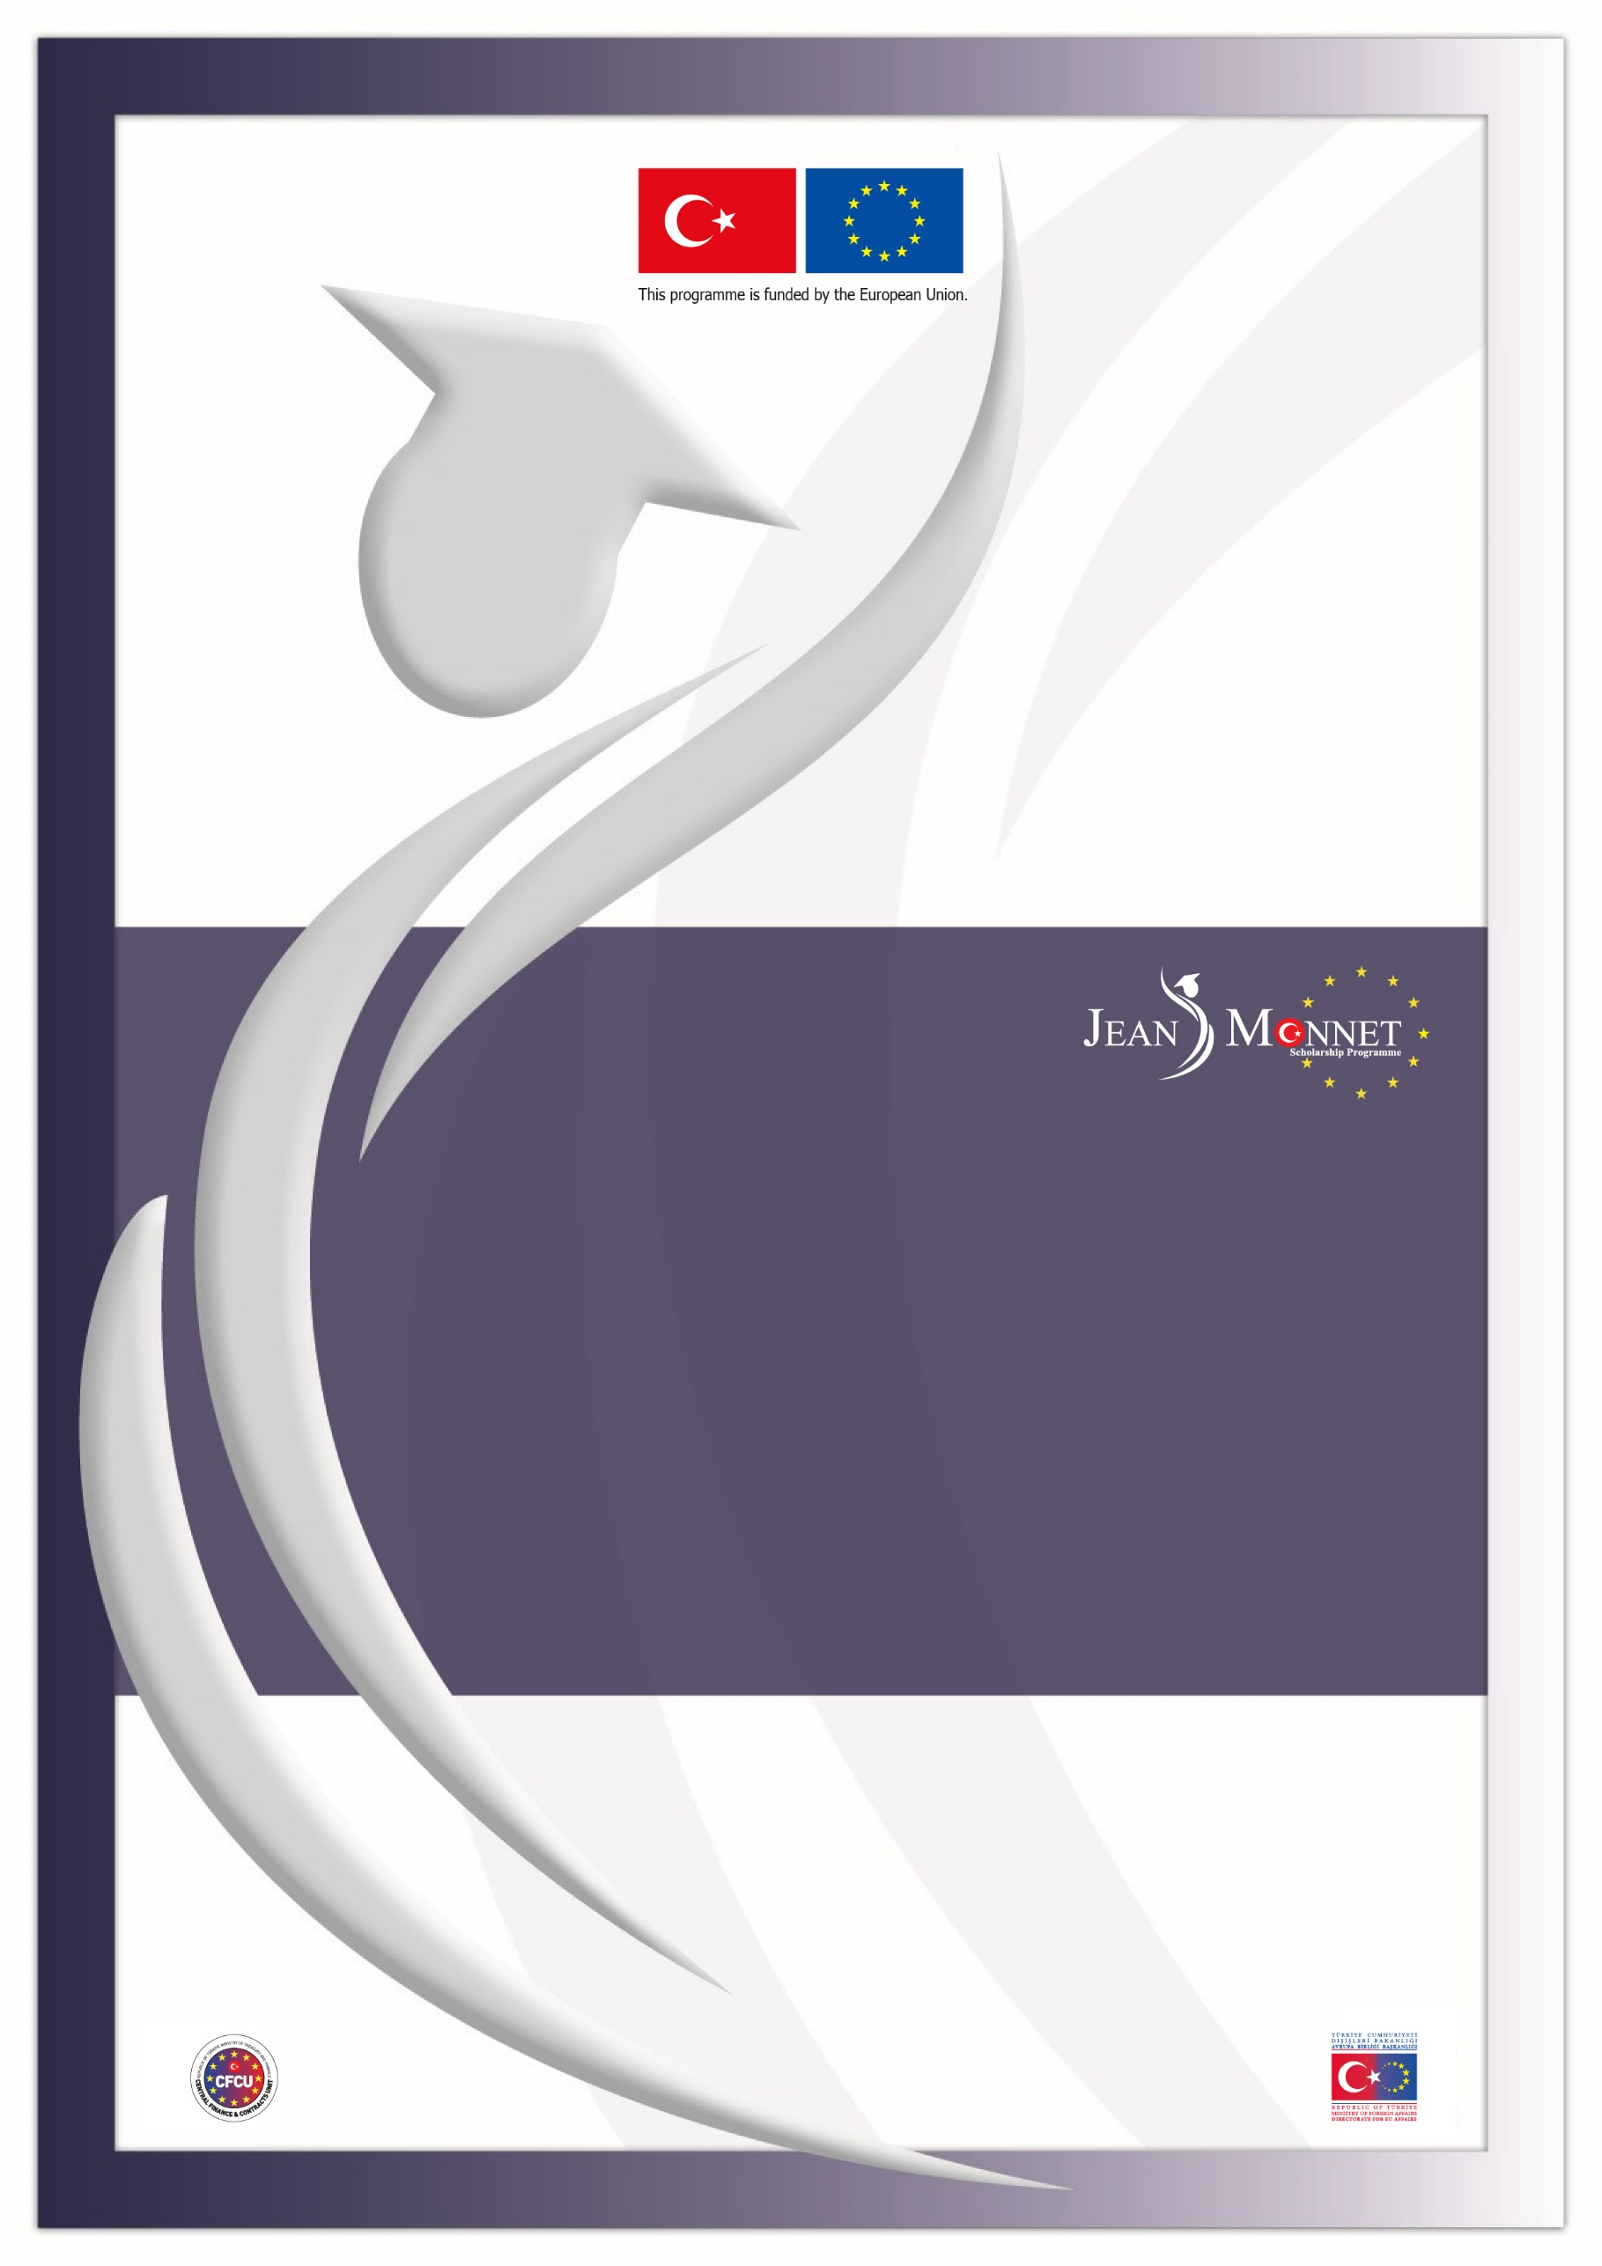

Directorate for EU Affairs Central Finance and Contracts Unit Delegation of the EU to Türkiye

TR2024/W2T2/A04/OT01-1
2026-2027 ACADEMIC YEAR
JEAN MONNET SCHOLARSHIP PROGRAMME
CLARIFICATIONS

IMPORTANT NOTICE
The questions received from potential applicants for the 2026-2027 academic year Jean Monnet Scholarship Programme together with their answers can be seen below. These questions and answers are valid for the 2026-2027 academic year Announcement and the questions and clarifications of the previous academic years do not set a precedent for the mentioned academic year.

Clarifications constitute an essential part of the Announcement; for this reason, the applicants must read the Clarifications document very carefully and pay attention to the details while applying to the scholarship.

Please note that the replies given to the questions on the eligibility are provided solely for the question asked without consideration of whether the other eligibility criteria stated in the Announcement are fulfilled or not.

As stated in Section 2.3.3. Important Notes for Application of the 2026-2027 Academic Year Jean Monnet Scholarship Programme Announcement, questions related to the issues clearly stated in the Announcement document will not be answered in the Clarifications document.

In the interest of equal treatment of applicants, the contracting authority or the Directorate for EU Affairs cannot give prior opinion/approval neither during application nor during evaluation stages, on:
- the acceptability/adequacy of the application documents,
- the sector from which the applicant should make an application,
- the eligibility of the academic programmes to be pursued,
- the relevance of the field of study (i.e. EU acquis chapter) with the academic programmes planned to be pursued.
SECTOR AND APPLICATION CRITERIA
1 | Q: I have graduated from an undergraduate/graduate programme. However, I neither started to work, nor am I registered to a master’s degree/PhD programme. May I apply?  C: No. In order to be eligible, applicants should either be working in Türkiye on a professional basis (i.e. under a social security network, in return for a wage) in public sector or private sector or university sector as academic/administrative staff or be senior undergraduate students/ master’s/PhD students in the universities in Türkiye.
2 | Q: I am a senior student in an open education (Açık Öğretim) undergraduate (4-year) programme. May I apply?  C: Yes.
3 | Q: As a distance learning (with or without thesis) master’s student enrolled in a university located in Türkiye, can I apply?  C: Yes.
4 | Q: I am currently a graduate student. However, during the written exam and at the time the scholarships are granted I will have completed my graduate programme. May I still benefit from the scholarship?  C: Yes. As long as applicants are registered as graduate students at the time of application, having graduated and being unemployed in the following stages do not pose a problem. Please also note that awardees who were graduate students while applying to this Announcement, should submit either a “Graduation Certificate/Diploma” or “student certificate” related to the graduate programme they applied from, before the contract signature.
5 | Q: I am currently a senior undergraduate student and will graduate in January-February 2026. May I apply?  C: Yes. Please also note that awardees who were “senior undergraduate students” while applying to this Announcement, must graduate from their programmes before submission deadline of the placement and contracting documents (i.e. 2 months after the date applicants are informed in writing or until 14 August 2026, whichever is later). These awardees should submit a Graduation Certificate/Diploma with an undergraduate transcript showing that their graduation CGPA is higher than either 2.70/4.00 or 70/100.
6 | Q: Am I expected to be still working in the same institution indicated in my application when I am awarded? After the award, can I resign or use my leave of absence?  C: Applicants have to submit an employment letter in order to prove they are still working in the same sector after they are awarded with the scholarship. In this respect, they are allowed to change their institution as long as they are still in the same sector. It is up to the applicants’ decision whether they would like to benefit from the scholarship by using their leave of absence or resigning.
7 | Q: After application, can we change our job title/area of business?  C: Yes. Changes of the institutions/job title/ area of business will be accepted on the condition that the candidate remained in the same sector (i.e. public/private/university).
8 | Q: Is it possible if the applicant leaves work permanently or has periods of unemployment after the application?  C: Applicants have to submit an employment letter in order to prove they are still working in the same sector after they are awarded with the scholarship. It is important to note that in any stage of the scholarship programme, applicants may be required to submit additional documents when the information provided is unclear and thus prevents the evaluation committee/contracting authority from conducting an objective assessment.
9 | Q: I am working as a public employee in X Ministry. I am on paid/unpaid leave due to X reason. Would being on “paid” or “unpaid” leave while applying for the scholarship be a problem?  C: No.
10 | Q: I work at a company whose shares belong to “X” institution which is established by law. May I apply from the public sector?  A: During the application stage, in the interest of equal treatment of applicants, prior opinion/approval cannot be given on the sector from which the applicant should make an application. Applicants should decide from which sector (public sector, university sector, private sector) they will be applying according to the legal and legislation of their institution and should submit the required application documents accordingly. However, it is recommended that relevant supporting documents are included within the application explaining the sector category selection.
11 | Q: The institution in which I'm currently working is a joint-stock company with public capital but subject to private law provisions, and its employees are governed by the Labor Law No. 4857. From which sector should I apply?  C: Please see C.10.
12 | Q: Is there a requirement regarding duration of work experience when applying for a scholarship?  C: Minimum 36-month work experience is only required from the applicants whose CGPA is less than 2.70/4.00 or 70/100. Otherwise, there is no minimum work experience requirement for application.
13 | Q: Would it be a problem if I am working part-time?  C: No. You may apply so long as you submit all the application documents related to the relevant sector.
14 | Q: According to the Attorneyship Law, being employed under a social security system will not form a barrier to pursue legal internship as long as it does not present a factual obstacle to the internship. May I apply for a scholarship if I work in the public or private sector under social security during my internship period?  C: Yes. Please also note that only applications from candidates whose retirement/pension insurance premiums are paid is acceptable.
15 | Q: I am currently pursuing graduate study abroad and at the same time working in the private/public sector in Türkiye. Can I apply to Jean Monnet Scholarship Programme?  C: Those who meet the required criteria and who can submit the required documents of the relevant sector may apply.
16 | Q: Can fifth year medical faculty student apply for the scholarship?  C: Medical school students’ application category depends on the regulations of the university they are enrolled in. Applicants must decide which category they will apply under and submit the appropriate application documents accordingly. It is recommended that relevant supporting documents are included within the application explaining the category selection. It should be also noted that if they are awarded the scholarship, those applying as senior undergraduate students must submit a diploma or graduation certificate, while graduate students must provide either a student certificate or a diploma/graduation certificate.
APPLICATION DOCUMENTS
17 | Q: I am an academic/administrative staff at the university. To apply for the scholarship, should I get the consent letter from my department chair or from a higher authority at my university?  C: The consent letter shall be signed by a superior who has the authorisation to approve the applicant’s academic study via the Jean Monnet Scholarship Programme in the relevant EU member country when he/she is awarded the scholarship.
18 | Q: As a senior undergraduate student, I took courses abroad within the Erasmus Programme last term, which is not yet reflected in my signed official university transcript. Can I apply?  C: Prior opinion/approval cannot be given on the adequacy of the application documents. However, you are recommended to submit supporting documents (preferably taken from the university) explaining your situation.
19 | Q: I will appear as a 3rd year student in my transcript document at the time of application. However, I will be a final year student in spring term and graduate in 2025-2026 academic year. May I apply?  C: Senior undergraduate students who are expected to graduate before the contracting process may apply to the Scholarship Programme. Although prior opinion/approval cannot be given on the adequacy of the application documents, it is recommended to submit supporting documents (preferably taken from the university) explaining this situation.
20 | Q: I am a master’s student at the thesis stage. In the spring semester of the 2025–2026 academic year, I will study at a university abroad through Erasmus+ learning mobility. I know that I need to submit a student certificate if I am awarded the scholarship. However, since I will not be enrolled in courses at my home university, my student certificate will state “passive student” or “on leave/Erasmus student” Will this be a problem?  C: Although prior opinion/approval cannot be given on the adequacy of the application documents, it is recommended to submit supporting documents (preferably taken from the university) explaining this situation.
21 | Q: Can I send an additional document or revise my documents after I have submitted my application?  C: It is solely the applicant’s responsibility to submit the application documents in a complete form to the Central Finance and Contracts Unit until the application deadline. If need arises to send any document after the submission of the application (no later than the application deadline), a petition letter explaining the situation in detail should also be attached to the document.
22 | Q: Can we use Turkish characters when filling the English Application Form?  C: You may use Turkish characters for proper nouns. In case any problem occurs while using Turkish characters, you can use the closest English character.
LANGUAGE PROFICIENCY CERTIFICATES
23 | Q: I have a language proficiency certificate for the test I took on 4 November 2023. May I apply with this certificate based on the fact that it is valid for 2 years?  C: Yes, you may apply with the language proficiency certificate taken on 4 November 2023 if it is valid for 2 years.
24 | Q: I retook the IELTS exam using the One Skill Retake option. Can I apply with this document?  C: Yes. Applicants can submit the IELTS One Skill Retake certificate as long as it includes scores for all sections and the overall band score. Please note that only the overall IELTS score will be taken into consideration, and there is no minimum score requirement for individual sections.
25 | Q: Should I take IELTS Academic on “computer” or “online” or “paper”?  C: All are acceptable for applying to the Scholarship Programme.
26 | Q: Can I submit the language proficiency certificate after the application deadline?  C: No.
HOST INSTITUTIONS & ACADEMIC PROGRAMMES
27 | Q: How many acceptance/offer letters do we need to get for the placement process?  C: It is obligatory that the applicants apply and get offer letters from at least two academic programmes which have to be in at least two different eligible host countries. The Directorate for EU Affairs will decide on the placement of the scholars based on the success rankings provided by the Evaluation Committee and considering the aim of achieving a balanced distribution of scholars throughout various eligible host countries. Should more than 50% of scholars prefer to study in the same EU member country, those with higher rankings shall be given priority for placement in that country. Scholars with lower rankings who have selected the same country will be placed in their next most appropriate programme alternative, i.e., in another EU member country.
28 | Q: Are master’s programmes that have a campus in an EU member state, and offer a double degree with universities in the UK/USA and EU countries, eligible for the scholarship?  C: Yes, as long as the whole academic study is conducted in the EU countries.
29 | Q: Are master’s programmes conducted at an EU campus of a UK-based university eligible for the scholarship?  C: Yes.
30 | Q: Are scholarships granted for post-doctoral study or research?  C: Jean Monnet Scholarships are not limited for master’s degrees only, meaning that scholarships can be granted for post-doctoral studies or research levels for periods of minimum 3 months, maximum 12 months. Academic studies longer than 12 months will not be supported even if the scholars are willing to fund the remaining period by their own means.
31 | Q: Does it make a difference if the master’s programmes under the scholarship are with or without a thesis?  C: No.
32 | Q: I have two separate undergraduate diplomas. If I apply to Jean Monnet Scholarship Programme with one of them, can I use another for getting offer letters from universities?  C: Yes.
33 | Q: Why is there no programme related to field “Y” in “X” country in the Host Institutions Catalogue?  C: Eligible programmes are not restricted to the programmes/institutions listed in the subject catalogue. Applicants should identify the EU member countries in which they would like to pursue their academic studies while the application and evaluation processes are going on. It is solely the applicants’ responsibility to get unconditional offer letters from the academic programmes. The academic programmes in the Catalogue and/or the academic programmes pursued by Jean Monnet Scholars in the previous academic years do not constitute a precedent for the following academic years.
34 | Q: Some programmes have 12 months of coursework and 6 months of internship, making a total of 18 months. Is it eligible to apply for such programmes?  C: No. Scholars shall conduct academic studies (including thesis and/or internship) at graduate or research level for periods of minimum 3 (three), maximum 12 (twelve) months. Academic studies longer than 12 months will not be supported even if the scholars are willing to fund the remaining period by their own means.
35 | Q: Is it possible to change or revise the academic research/thesis topic indicated for the chosen field of study during the graduate programme?  C: Scholars enrolled in graduate programmes with a thesis may change their courses and/or thesis topic with the prior approval of the Directorate for EU Affairs, as long as the relevance of the programme with their field of study is maintained. However, scholars conducting research are required to amend their contract if they wish to change their research topic.
36 | Q: In what format and where should the research proposal be submitted for research programmes?  C: Applicants should not submit offer letter(s) or research proposals from the universities or similar institutions together with the application documents at the time of application. Relevant documents will be required from the applicants who are awarded the scholarship later on (during the programme approval and placement process).
37 | Q: Universities may request payments when issuing acceptance/offer letters. Are we responsible for making these payments?  C: It is solely the applicants’ responsibility to identify the suitable academic or research programmes in line with their field of study and to obtain acceptance/offer letter(s) from the academic programmes. On the other hand, the risk of the academic or research programme for which a deposit/tuition fee has been paid not being approved should be noted, as the Directorate for EU Affairs retains the right to give the final decision on the programme approvals to ensure the compliance of the programmes with the fields of study (EU acquis chapters) and the optimal exploitation of the scholarships. Please also note that the Directorate for EU Affairs will decide on the placement of the scholars based on the success rankings provided by the Evaluation Committee and considering the aim of achieving a balanced distribution of scholars throughout various eligible host countries.
OTHER
38 | Q: I completed a graduate degree funded by the United Kingdom (e.g. Chevening, GREAT, etc), can I apply for a Jean Monnet scholarship?  C: Yes.
39 | Q: Last year I completed my Master's degree with a scholarship by the Lazio DiSCo in Italy. May I apply for the Jean Monnet Scholarship?  C: Those who have earned a graduate degree (master’s or PhD) abroad by benefitting from another scholarship funded by an EU member country or an EU institution (Exchange programmes such as Erasmus or short-term academic/language scholarships are not considered in this category) are not eligible for the scholarship.
40 | Q: May I benefit from Jean Monnet Scholarship Programme, if I am the recipient of another scholarship for the same academic study?  C: Jean Monnet Scholarship recipients may not benefit from another scholarship for the same duration of study. However, scholars may benefit from tuition fee discounts/waivers of host institution, if any.
41 | Q: As a dual citizen, I have a Turkish ID Card and EU Passport. Can I apply with my EU passport? Will not having a Turkish passport be a problem?  C: Nationals of EU member countries, Türkiye or Instrument for Pre-Accession Assistance (IPA) beneficiary countries may apply to the Jean Monnet Scholarship Programme. It is at the discretion of the applicant to decide which nationality to use while applying. Those who are nationals of countries other than Türkiye, should submit their passport photocopies. Turkish citizens may submit photocopies of either their Turkish ID card or Turkish passport.
42 | Q: As a dual citizen, the names on my Turkish ID and Bulgarian passport are different. I will apply using my Bulgarian passport. How should I write my name in the application form? Will it be a problem if my name appears differently in application documents, such as the student certificate?  C: You should fill out the application form using the name as it appears on the document you will submit during the application process. If your name or surname appears differently in other application documents, you must provide an official document that explains or verifies the discrepancy.
43 | Q: According to the Announcement, applicants who are nationals of countries other than Türkiye are required to submit a passport photocopy. However, my EU passport expired and cannot be renewed till 4 November. May I apply with my expired passport?  C: All the official documents submitted should be valid during application.
44 | Q: How long does contracting process take after being awarded?  C: Scholars should submit their placement and contracting documents before the deadline of the placement and contracting process (i.e. 2 months after the date applicants are informed in writing or until 14 August 2026, whichever is later). The signing of the contract is dependent on the dates when scholars submit their documents as well as receipt of approval from the programme authorities.
45 | Q: When applying, does the address I provide have to be my official residence address? If my address changes after being awarded the scholarship, will it be a problem?  C: The address stated in the application form must be current and reachable if needed. Applicants who are awarded the scholarship should inform the programme officials of any changes to their contact information.
46 | Q: May I visit Jean Monnet Scholarship Programme office to ask questions?  C: No.
47 | Q: I will apply from the private sector. Will my employer be contacted during the evaluation process?  C: No.
48 | Q: If I am awarded the scholarship, can I continue a distance learning master’s programme in Türkiye while studying abroad?  C: Yes.

